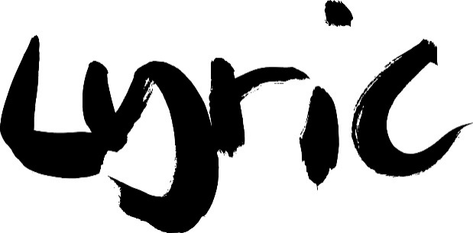

Equal Opportunities Monitoring Form
Please complete this form to help us ensure that we are complying with our Equal Opportunities policy which states that nobody who works at the Lyric Hammersmith will receive less favourable treatment on the grounds of ethnic origin, gender, disability or age.
As a publicly funded organisation, the Lyric is required to monitor the cultural diversity of all its employees, freelancers, Board members, and volunteers.
The information you provide will be used for monitoring purposes only and all data will be aggregated and anonymised. The forms will be kept securely and will not be shown to colleagues or third parties without your consent. No decisions will be made or action taken about a person based on their answers to the questions.
Please contact the Lyric’s HR Manager, Amir Sheikh, at amir.sheikh@lyric.co.uk or 020 8741 6822 (option 2) if you have any queries.

I consent to the data I provide below being kept in this manner and only used for the purposes explained above:
Name: …………………………..............................................
Signature: ………………………….........................................
Date: ......................................................................................

1. How would you describe your ethnic origin?
Please choose one section from A to F, and then tick the appropriate box to indicate your cultural background
Section A: White
( ) British (English/Welsh/Scottish/Northern Irish/British)
( ) Irish
( ) Gypsy Or Irish Traveller
( ) Any Other White Background, Please Write Here …………….…………………………………
Section B: Mixed
( ) White and Black Caribbean
( ) White and Black African
( ) White and Asian
( ) Any Other Mixed Background, Please Write Here …………….…………………………………
Section C: Asian Or British Asian
( ) Indian
( ) Pakistani
( ) Bangladeshi
( ) Chinese
( ) Any Other Asian Background, Please Write Here …………….…………………………………
Section D: Black or Black British
( ) African
( ) Caribbean
( ) Any other Black/African/Caribbean background – please write here …………….………………
Section E: Arab or Other Ethnic Group
( ) Arab
( ) Any other ethnic group, please write here …………….…………………………………
Section F: Prefer not to say
( ) Prefer not to say
2. a) How would you describe your gender?
( ) Female
( ) Male
( ) Non-binary
( ) Prefer not to say
b) Is your gender the same as the gender you were assigned at birth?
( ) Yes ( ) No
3. Do you consider yourself to be disabled?
( ) Yes ( ) No ( ) Prefer not to say
If you have answered yes, please indicate the type of impairment which applies to you:
( ) Visual impairment
( ) Hearing impairment/deaf
( ) Physical disabilities
( ) Cognitive or learning disabilities
( ) Mental health
( ) Other long-term / chronic conditions
4. How would you describe your sexual orientation?
( ) Bisexual
( ) Gay man
( ) Gay woman / lesbian
( ) Heterosexual / straight
( ) Prefer not to say
5. What is your age?
( ) 0-19
( ) 20-34
( ) 35-49
( ) 50-64
( ) 65+
( ) Prefer not to say

Please return this completed form to contracts@lyric.co.uk.

