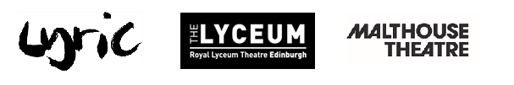
Lyric Hammersmith Theatre, Malthouse Theatre and
Royal Lyceum Theatre Edinburgh announces
Polly Frame to play Kris Kelvin in UK Run of Solaris
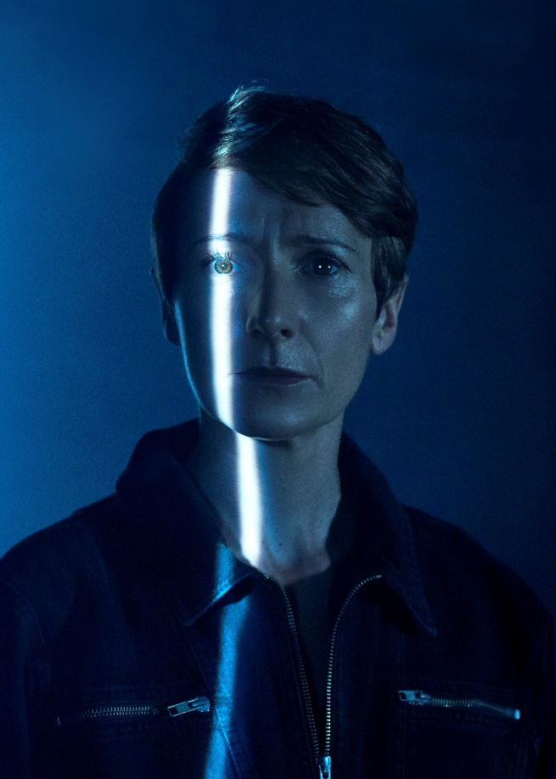
- Polly Frame stars as Kris Kelvin in Solaris at the Lyric Hammersmith Theatre and Royal Lyceum Theatre Edinburgh
- Hugo Weaving plays Gibarian, who features via video in the production
- On stage cast includes Keegan Joyce as Ray, Jade Ogugua as Sartorius, Fode Simbo as Snow

- Based on the classic sci-fi novel by Stanisław Lem, published in 1961 and previously tackled by film giants Andrei Tarkovsky and Steven Soderbergh, David Greig adapts the novel for this major new stage production, which opened in Melbourne in June 2019
- Solaris will play at the Lyric Hammersmith Theatre from 10 October, following a run at the Royal Lyceum Theatre Edinburgh
Today, the Lyric Hammersmith Theatre, Royal Lyceum Theatre Edinburgh and Malthouse Theatre announce Polly Frame as the actor playing Kris Kelvin in the UK run of David Greig’s adaptation of Stanisław Lem’s Solaris.
Polly’s most recent roles include After Edward and Edward II, The Globe; Thick as Thieves, Clean Break Theatre; Fringe First winner On the Exhale, China Plate, Traverse Theatre, Oxford Playhouse; Jekyll & Hyde, Rose Kingston & No 1 Tour; A Short History of Tractors in Ukranian, Hull Truck, Dr Frankenstein and Hedda Gabbler, Northern Stage & Tour, and Henry V, Regent’s Park.
The cast further includes internationally celebrated actor, Hugo Weaving (Lord of the Rings trilogy, Cloud Atlas, The Matrix trilogy, V for Vendetta, The Adventures of Pricilla, Queen of the Desert), who features via video as Gibarian, the ill-fated doctor whose love and fascination for the mysterious planet Solaris causes his mysterious demise just before Kelvin arrives on board the space station.
The original footage accompanies performances from an international cast, including Jade Ogugua (Twelfth Night, The Lyceum and Bristol Old Vic; How to Act, National Theatre Scotland; The Tempest, Northern Stage & Oxford Playhouse); Keegan Joyce (Rake, Please Like Me, Superman Returns) and Fode Simbo (The Princess and the Hustler, Eclipse Theatre, Bristol Old Vic; Young Marx, Bridge Theatre; Summer of Rockets, Little Women, both BBC).
Speaking of the production, David Greig said: “Writing the adaptation for Solaris was as fascinating as exploring a newly discovered planet. I had no idea Stanisław Lem’s book was so funny, so moving, and such a fascinating philosophical disquisition on the eternal human problem of our relationship with ‘the other’ – whether that other is a person, a planet, a lover or a monster. The premise is simple: there are three scientists on a space station orbiting a great planet, a psychologist arrives to check on their wellbeing, and strange things start to happen – is the planet communicating with them? Or are they imagining it? Is it a god? Or a demon? Or a child?
Solaris will transfer to the Lyric Hammersmith Theatre on 10 October 2019, running until 2 November 2019 – before that, it will open The Lyceum 19/20 season on 12 September, running until 5 October 2019.
STUDIO TALK AT THE LYRIC HAMMERSMITH THEATRE:
Studio Talk hosted by Fiona Mountford invites members of the creative team and special guests from theatre, culture, politics and journalism to discuss and debate a topic inspired by the Lyric Hammersmith Theatre’s current Main House production.
Studio Talk: Solaris – Staging outer space in theatre and film
Tuesday 29 October 2019, 6pm

Panel includes:
- Fiona Mountford – Fiona was a theatre critic at the Evening Standard for 17 years. Also well as writing (many thousands of) reviews, she wrote feature interviews, talking to almost all of London’s leading theatre makers. She also wrote arts interviews and comment pieces for the Independent on Sunday before its sad demise. Fiona read Classics at Cambridge and has previously worked for the Daily Telegraph, Sunday Telegraph and Time Out. For the past decade she has chaired Platforms at the National Theatre with a wide range of theatre practitioners spanning actors, writers, directors and academics. She also chaired the ‘Talking Twelfth Night’ and ‘Talking Lear’ Platform series. Fiona currently hosts a range of events and talks at theatres across London. For the Southbank Centre, she chaired an in-depth Stephen Sondheim study day. She was a judge for the Peter Brook: Empty Space Awards and led workshops for students as part of Mousetrap Theatre Projects’ Play the Critic scheme.
- Rachel O’Riordan - Rachel was appointed the Artistic Director of the Lyric Hammersmith Theatre in February 2019. Rachel was the Artistic Director and CEO of Sherman Theatre from February 2014 – February 2019. During her tenure the theatre was transformed into a vibrant, exciting and influential producing theatre, winning The Stage’s prestigious Regional Theatre of the Year Award in 2018. Her credits as a director for the theatre include: The Cherry Orchard; the Olivier award-winning Killology (with the Royal Court); Bird (with the Royal Exchange) and Iphigenia in Splott (also at the National Theatre; England tour, Edinburgh Festival, Schaubūne, Berlin and off-Broadway).
- Will Massa is the Curator of Contemporary Fiction in the BFI National Archive, ensuring contemporary British fiction film is comprehensively represented in the national collection. He is currently helping to pioneer a framework for the acquisition of ‘new forms’ such as VR, multimedia and VFX into the archive. He previously worked in the British Council’s Film department, at various regional screen agencies in talent development, as a film festival programmer, a project assessor and a script consultant. He currently serves on the board of Encounters Short Film and Animation Festival. Will has an MA in World Cinema from the University of Leeds and has specialist interest in short film, the relationship between ‘export cinema’ and soft power, British poetic realism, representations of class and masculinity in 90s British cinema, and the intersection between film and new technologies.
- Brendan Owens is an Astronomer from the Royal Observatory, Greenwich. Brendan’s academic background includes a B.Sc. in Physics with Astronomy and an M.Sc. in Science Communication, both from Dublin City University. After joining the team at the Royal Observatory Greenwich in 2010, Brendan has presented school and public events to a wide variety of audiences. Now he plans the public astronomy programme for the Royal Observatory, including monthly Silver Screen Science Fiction film screenings in the Peter Harrison Planetarium. The films on show are always followed by a talk that teases out the science fact in the science fiction, sometimes in a humorous fashion and other times in a very deep and thought-provoking way. Brendan is an avid fan of science fiction and is fascinated by the driving inspirational force of fact on fiction and vice versa.

For further information, press requests, and images, please contact the Lyric Hammersmith Theatre PR and Media Officer Armani Ur-Rub on Armani.ur-rub@lyric.co.uk / 020 8741 66822 (ext 429)
Or
The Lyceum Press and PR Manager Harriet Mould on press@lyceum.org.uk / 0131 2484 822 / 0745 4816 116
ENDS
Full listings information
Solaris
A new play by David Greig
Adapted from Stanisław Lem’s novel
Directed by Matthew Lutton

12 September – 5 October 2019
Royal Lyceum Theatre, Edinburgh
Press Night: Saturday 14 September, 2019

10 October – 2 November 2019
Lyric Hammersmith Theatre, London
Press Night: Monday 14 October, 2019
Cast
Polly Frame – Kris Kelvin
Keegan Joyce - Ray
Jade Ogugua – Dr Sartorius
Fode Simbo - Dr Snow
Hugo Weaving – Dr Gibarian

Royal Lyceum Theatre Edinburgh
Address: The Royal Lyceum Theatre Edinburgh, Grindlay Street, Edinburgh, EH3 9AX
Box Office: 0131 248 4848 / boxoffice@lyceum.org.uk
Group Bookings: 0131 248 4949
Website: lyceum.org.uk
Lyric Hammersmith Theatre
Address: Lyric Hammersmith Theatre, Lyric Square, King Street, London, W6 0QL
Box Office: 020 8741 6850
Website: lyric.co.uk

Notes to Editors
The Lyric Hammersmith Theatre is one of the UK's leading producing theatres; creating world class theatre from the heart of Hammersmith, the theatre’s home for more than a hundred and twenty years.
The Lyric has two stages – a Frank Matcham designed traditional Victorian Main House and a flexible contemporary Studio theatre. The theatre’s Reuben Foundation Wing, which opened in 2015, houses state-of-the-art creation and arts education facilities for theatre, dance, film, digital and music.
At the heart of the Lyric is a commitment to young people’s creativity. The theatre has gained a national reputation for its ground breaking work to forge pathways into the arts for young talent from all backgrounds, helping to diversify our industry. Central to the Lyric’s work is a commitment to providing opportunities for children and young people who are disadvantaged. The Lyric is the largest creative hub in West London and home to an innovative partnership of arts organisations who work together to deliver life-changing creative opportunities for thousands of young West Londoners. www.lyric.co.uk
Free First Night at Lyric Hammersmith Theatre

The Lyric is proud to call Hammersmith their home. In 2016 they celebrated the 20th anniversary of their Free First Night scheme, part of their long term partnership with the London Borough of Hammersmith & Fulham, through which they give free tickets to people who live or work locally. Through this scheme last year they offered 3799 Free First Night tickets to people who may not have had an opportunity to see theatre before. And as part of this commitment to the local community, they also provided 2,000 tickets to Hammersmith & Fulham schools.

The Royal Lyceum Theatre Edinburgh is the leading producing theatre in Scotland and one of the United Kingdom’s most prolific theatre companies. Our beautiful, intimate Victorian theatre was built in 1883 and has played a significant role in the cultural and creative life of the city and surrounding area for over 130 years. Since 1965, the current Lyceum company has developed a reputation for innovative, high-quality theatre, drawing upon the considerable talent in Scotland as well as developing award winning work with partners across the globe to make theatre in Edinburgh, that can speak to the world.

We believe that making and watching theatre together is life enhancing. We are committed to being a theatre rooted in our community, a truly civic theatre entertaining, challenging and inspiring all the people of Edinburgh. To reach the widest possible audience we find new ways to open our doors and our stage to the public, as well as reaching out into Edinburgh’s schools and neighbourhoods with a range of programmes taking place beyond our walls. Under Artistic Director David Greig, The Lyceum has continued to seek out new artistic partnerships, casting 100 local citizens in our main stage production of The Hour We Knew Nothing of Each Other and 50 more in The Suppliant Women, the acclaimed production that opened David’s first season. Since then we have made work with Malthouse Theatre, Melbourne; DOT Theatre, Istanbul; Bristol Old Vic; National Theatre of Scotland; Citizens Theatre; Scottish Dance Theatre; Stellar Quines; Lung Ha; and Fuel.

Malthouse Theatre is Australia’s most boundary-pushing theatre company. Collaborating with local and international artists, Malthouse Theatre creates inventive performances that cut to the core of the human experience. Led by Co-CEOs Matthew Lutton and Sarah Neal, Malthouse Theatre is committed to the power of theatre to interrogate, disrupt and to be an agent of change. Our work explores the world personally, socially and politically. Based in a dedicated venue, The Coopers Malthouse in Melbourne, ours is a home for live experiences that entertain and provoke a dialogue with and within audiences. For more information, please visit malthousetheatre.com.au.

