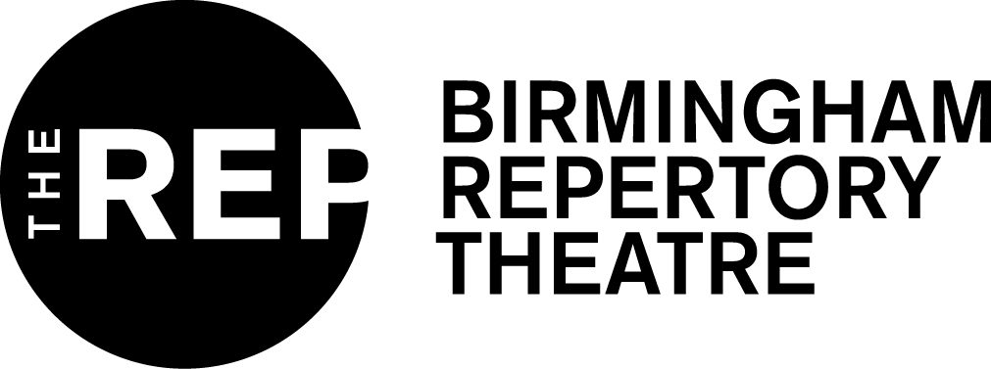
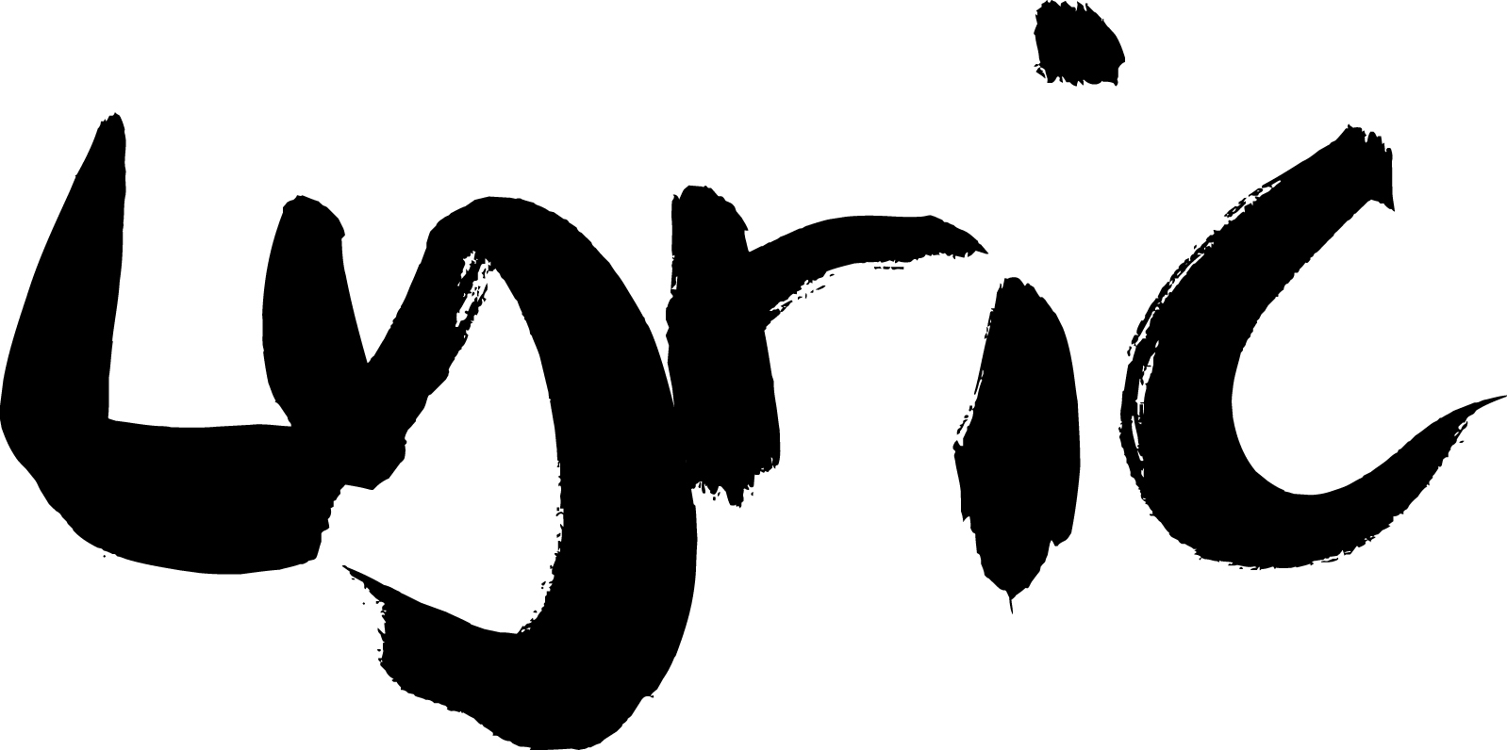
PRESS RELEASE – 30 OCTOBER, 2019

JODIE MCNEE AND DANNY LEE WYNTER CAST IN
FAUSTUS: THAT DAMNED WOMAN

A Headlong and Lyric Hammersmith Theatre co-production,
in association with Birmingham Repertory Theatre

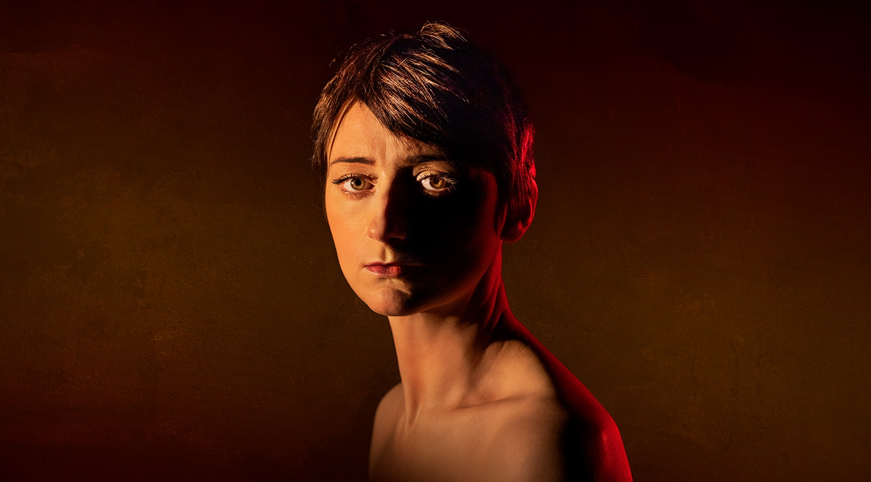

Jodie McNee (Venice Preserved, Anatomy of a Suicide) and Danny Lee Wynter (The Maids, Comus) have been cast in Faustus: That Damned Woman, a new play from award-winning playwright and theatre maker Chris Bush (Standing at the Sky’s Edge), directed by Caroline Byrne (All’s Well That Ends Well). Jodie McNee will play the title role of Johanna Faustus with Danny Lee Wynter cast as Mephistopheles. This is the first work to be commissioned as part of Headlong and the Lyric Hammersmith Theatre’s long-term commitment to commissioning and producing work of scale by women playwrights.

Faustus: That Damned Woman will premiere at the Lyric Hammersmith Theatre on 22 January 2020 before playing at Birmingham Repertory Theatre from 26 February 2020. The production will then tour throughout the Spring visiting Bristol Old Vic, Leeds Playhouse and Northern Stage from March to April 2020.

Drawing on the works of Marlowe, Goethe, and other versions of the Faustus myth, Chris’ urgent reimagining asks what we must sacrifice to achieve greatness and the legacy that we leave behind.

"My name is Johanna Faustus. I was born almost four hundred years ago.
I gave my soul to achieve the impossible.
I watched this city grow sick and I swore to heal it.
I might be damned, but I would save the world to spite the Devil.”

Caroline Byrne directs this radical new work in which the iconic character of Faustus is reimagined as a woman who makes the ultimate sacrifice to traverse centuries and alter the course of history. The creative team include set designer Ana Inés Jabares-Pita, costume designer Line Bech, lighting designer Richard Howell, sound and composition designer Giles Thomas, video and projection designer Ian William Galloway, Movement Director Shelley Maxwell and casting director Annelie Powell CDG. Further casting will be announced shortly.

Jodie McNee is a critically acclaimed actress known for her work on stage and screen. Her extensive theatre credits include Venice Preserved (RSC), Anatomy Of A Suicide (Royal Court Theatre), The Night Watch, Hamlet, Orpheus Descending, A Taste of Honey (Royal Exchange, Manchester); An Oak Tree, Our Country’s Good, Three Winters (National Theatre); Game (Almeida); A Life of Galileo, Written on the Heart, Measure for Measure (RSC); Hobson’s Choice (Regent’s Park Open Air); Canary, When We Are Married, Twelfth Night (Liverpool Everyman Playhouse); The Empty Quarter (Hampstead Theatre); When We are Married (West End); The Frontline, King Lear (Shakespeare’s Globe); Seagull, Knives in Hens, Double Portrait, Jenufer (Arcola) Cymbeline, The Changeling (Barbican/ International tour); Mother Courage, This Happy Breed (ETT) and The Burial at Thebes (Playhouse, Nottingham).

Jodie’s television credits include Britannia series 1 & 2, Vera, Little Boy Blue, Ripper Street, Criminal Justice, Poirot and The Liverpool Nativity. Her film credits include Judy, Official Secrets, Film Stars Don’t Die in Liverpool and The Physician, whilst her radio credits include Zola: Blood Season and With Great Pleasure.

Danny Lee Wynter is an actor known for his work across stage and screen. He is the founder of the campaign and charity Act For Change. Danny’s theatre credits include The Maids (HOME, Manchester), Cell Mates (Hampstead Theatre), Forty Years On (Chichester Festival Theatre), Deathwatch (The Print Room), The Glass Menagerie (Nuffield Southampton), Much Ado About Nothing (Old Vic), St John’s Night (Jermyn Street Theatre), The Miser (Manchester Royal Exchange), The Changing Room (Royal Court Theatre), Comus, Bedlam, Henry IV Part II, Henry IV Part 1, King Lear, The Frontline (Shakespeare’s Globe).

Danny’s TV and film credits include the lead in Stephen Polaikoff’s Joe’s Palace & Capturing Mary, Luther, Hot Fuzz, Walliams and Friend, The Dreams of Bethany Mellmoth, Partners in Crime, Holby City, Mr Stink, Episodes, Beat Girl, Trial and Retribution and the forthcoming film Censor.

-ENDS-

For further information please contact The Corner Shop PR on
020 7831 7657 | kateh@thecornershoppr.com

LISTINGS
FAUSTUS: THAT DAMNED WOMAN
by Chris Bush
Directed by Caroline Byrne
Set Designer – Ana Inés Jabares-Pita
Costume Designer – Line Bech
Lighting Designer – Richard Howell
Sound and Composition Designer – Giles Thomas
Video and Projection Designer – Ian William Galloway
Movement Director – Shelley Maxwell
Casting Director – Annelie Powell CDG

Johanna Faustus – Jodie McNee
Mephistopheles – Danny Lee Wynter
Lyric Hammersmith Theatre
Lyric Square, King St, Hammersmith, London W6 0QL
22 January – 22 February 2020
Press Night: Tuesday 28 January
https://lyric.co.uk/shows/faustus-that-damned-woman/
Studio Talk: Faustus: That Damned Woman – Interpreting Faustus: Marlowe through modern eyes
Tuesday 18 February, 6pm
Panel to include Fiona Mountford (host) and Chris Bush.

Studio Talk is a new programme of pre-show events hosted by Fiona Mountford, each inspired by the Lyric’s Main House productions, as part of Rachel O’Riordan’s first season as Artistic Director.

Free First Night (Wednesday 22 January):

The Lyric is proud to call Hammersmith their home. In 2016 they celebrated the 20th anniversary of their Free First Night scheme, part of their long-term partnership with the London Borough of Hammersmith & Fulham, through which they give free tickets to people who live or work locally. Through this scheme last year, they offered 3799 Free First Night tickets to people who may not have had an opportunity to see theatre before. And as part of this commitment to the local community, they also provided 2,000 tickets to Hammersmith & Fulham schools. For full details including dates of future Free First Nights, www.lyric.co.uk.

Birmingham Repertory Theatre
Centenary Square, Birmingham B1 2EP
26 February – 7 March, 2020
Press Night: Wednesday 26 February
https://www.birmingham-rep.co.uk/

BIOGRAPHIES

CHRIS BUSH
Chris Bush is an award-winning playwright, lyricist and theatre maker. Her writing credits include Standing at the Sky’s Edge, a collaboration with musician Richard Hawley, Steel (both Sheffield Crucible Theatre), The Assassination of Katie Hopkins (Theatr Clwyd), Pericles (NT) and The Changing Room (NT Connections).

CAROLINE BYRNE
Caroline Byrne is known for her distinctive and innovative direction. Her theatre credits include Spring Awakening (Young Vic), All’s Well That Ends Well (Sam Wanamaker Theatre), Katie Roche (Abbey Theatre, Dublin) Oliver Twist (Regents Park) and Taming of the Shrew (Shakespeare’s Globe Theatre). Her upcoming work includes Portia Coughlan starring Ruth Negga (Young Vic).

NOTES TO EDITORS

Headlong
Headlong is one of the most ambitious and exciting theatre companies in the UK, creating exhilarating contemporary theatre: a provocative mix of innovative new writing, reimagined classics and influential 20th century plays that illuminate our world. Headlong make bold, ground-breaking productions with some of the UK’s finest artists. We take these industry-leading, award-winning shows around the country and beyond, in theatres and online, attracting new audiences of all ages and backgrounds. We engage as deeply as we can with these communities and this helps us become better at what we do. In 2019 Headlong’s revealing new production of Richard III toured the UK with Tom Mothersdale playing the iconic villain, while Cordelia Lynn’s vital exploration of motherhood, power and sabotage, Hedda Tesman, played at Chichester Festival Theatre and The Lowry.

Lyric Hammersmith Theatre
The Lyric has created some of the UK’s most adventurous and acclaimed theatrical work. This includes the debuts of Harold Pinter’s The Birthday Party (1958) and Michael Frayn’s Noises Off (1982), which returned this year and opened in the West End late September. Other iconic productions include the Olivier award-winning revival of Sarah Kane’s Blasted (2009), the triumphant Bugsy Malone (2015) and the international cult hit Ghost Stories, which is back in the West End until January 2020.

Under the joint leadership of Artistic Director Rachel O’Riordan and Executive Director Sian Alexander, the Lyric’s 2019/2020 programme of reimagined classics, contemporary plays and bold new works celebrates its unique Matcham theatre.

At the heart of the Lyric is a commitment to young people’s creativity. The theatre has a national reputation for its ground breaking work to forge pathways into the arts for young talent from all backgrounds, helping to diversify our industry. The theatre is West London’s largest creative hub and home to an innovative partnership of arts organisations who work together to deliver life-changing creative opportunities for thousands of young West Londoners.

Birmingham Repertory Theatre
Birmingham Repertory Theatre is one of Britain’s leading producing theatre companies. Its mission is to inspire a lifelong love of theatre in the diverse communities of Birmingham and beyond. As well as presenting over 60 productions on its three stages every year, the theatre tours its productions nationally and internationally, showcasing theatre made in Birmingham.

The commissioning and production of new work lies at the core of The REP’s programme and over the last 15 years, the company has produced more than 130 new plays. The theatre’s outreach programme engages with over 7000 young people and adults through its learning and participation programme, equating to 30,000 individual educational sessions. The REP is also committed to nurturing new talent through its youth theatre groups and training for up and coming writers, directors and artists through its REP Foundry initiative.

Many of The REP’s productions go on to have lives beyond Birmingham. Recent tours and transfers include The Lovely Bones, Brief Encounter, Nativity! The Musical, What Shadows, LOVE, The Winslow Boy, The Government Inspector, Of Mice and Men, Anita and Me, Penguins and The King’s Speech. The theatre’s long-running production of The Snowman celebrated its 25th anniversary as well as its 21st consecutive season at London's Peacock Theatre in 2018.

