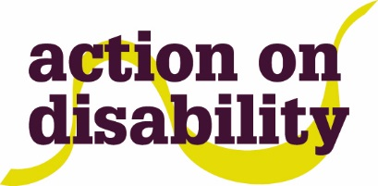

**ACTING UP**

**ENROLMENT FORM**

Please complete the form below and send to tamara.stuiver@aod.org.uk

|  |  |  |
| --- | --- | --- |
| Name: | Date of birth:  Age: | Gender: Male/Female/Other |
| Emergency Contact Name: | Relationship to participant: | Telephone number: |

|  |
| --- |
| Do you have any access requirements? |
| If yes, please provide any details: |

|  |
| --- |
| Do have any medical conditions or allergies that we should be aware of? |
| If yes, please provide any details: |

Anything else you would like us to know?

AOD/Lyric may photograph/film activities which may be used for promotional purposes. Please tick the box to indicate that you consent to

this.



The below section should be completed by a parent/guardian if participant is under 18 years of age.

|  |  |  |
| --- | --- | --- |
| Signature: | Print name: | Date: |

**Data Protection**

Action on Disability (AoD) takes your privacy very seriously. When you share information with us, we will always tell you how we will use it. We always act on your instructions to put you in control of the information you share and your relationship with us. For a full version of our privacy statement and policy go to <https://www.aod.org.uk/privacy-cookies/>

The information detailed in this membership form is used to minimize risk and to provide appropriate support. Action on Disability youth service will review consent and information held at AoD annually. If at any time you would like to access your information or would like to remove the information we hold, then please contact us. Some of our projects are contracted by LBHF youth services and are delivered with partner agencies. Other projects rely on specific income from charities, trust funds and central government. In order to meet funding requirements, we often have to share your personal and sensitive information. For specific information about what we share and with whom please discuss with the youth service team.